INPUT PROCESSOR

input processor INTERFACE
- InputProcessor is an interface with events managed for libgdx.
- It’s used to capture input data from keyboard, mouse and mobile device.

public interface InputProcessor {

public boolean keyDown(int i);

public boolean keyUp(int i);

public boolean keyTyped(char c);

public boolean touchDown(int i, int i1, int i2, int i3);

public boolean touchUp(int i, int i1, int i2, int i3);

public boolean touchDragged(int i, int i1, int i2);

public boolean mouseMoved(int i, int i1);

public boolean scrolled(int i);
}

input processor INTERFACE
Keyboard Input Events
- keyDown(): Called when a key was pressed
- KeyUp(): Called when a key pressed was lifted.
- KeyTiped(): Called when a character was generated trough keyboard.



input processor INTERFACE
Mouse And Device Mobile Input Events
- touchDown: Called when a finger touch down screen or when the button mouse was pressed.
- touchUp(): Called when a finger was lifted from screen or when the button mouse was left.
- touchDragged(): Called when the finger is sliding about screen or when the mouse is being moved while a button is pressed.


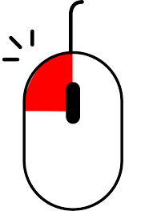

input processor INTERFACE
Mouse Movement Events
- mouseMoved(): Called when the mouse has been moved
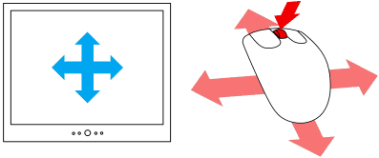
- scrolled(): Called when the wheel mouse is turned.

input processor INTERFACE
Using InputProcesor
- If you want to use inputProcesor, it’ll have to create a class that inherits from the interface. This implies that their methods will be implemented.

public class MyInput implements InputProcessor {
//All Methods
}

- Once implemented you must create the object and associate it.

MyInput x=new MyInput();
Gdx.input.setInputProcessor(x);

input adapter CLASS
- This class is an adapter for InputProcessor and contain all their methods.
- Every method for default return false.
- To implement, you can create a class and extend input adapter or you do a class anonymous.

Gdx.input.setInputProcessor(new InputAdapter(){

@Override
public boolean keyTyped(char character) {

return true;
}

});

- An advantage, you don’t need to overwrite all methods InputProcessor.

bibliography
- https://github.com/libgdx/libgdx/wiki/Event-handling
- https://libgdx.badlogicgames.com/ci/nightlies/docs/api/com/badlogic/gdx/InputProcessor.html
- https://libgdx.badlogicgames.com/ci/nightlies/docs/api/com/badlogic/gdx/InputAdapter.html
- https://www.youtube.com/watch?v=p-tSHxlLl0I
- https://www.youtube.com/watch?v=1OiBblP0AAk

